Data Structures & algorithms

Abdul Munim

Sap Id: 55470

**Lab 02**

1. Write down a program in C++ that take an age of 10 students as an input from user and display the largest age of the student from an array.

#include <iostream>

using namespace std;

int main()

{

int a[10]{};

int maxage = 0, i, j;

for (i = 0; i < 10; i++)

{

cout << "\n Enter the age of the student at index " << i << " = ";

cin >> a[i];

}

for (j = 0; j < 10; j++)

{

if (a[j] > maxage)

{

maxage = a[j];

}

}

cout << "\n" << maxage << " is the MAXIMUM AGE of the student" << endl;

}

**Output**

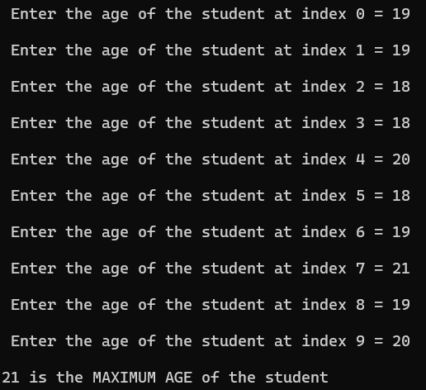

1. Write down a program in C++ that take an input from user in three different arrays and then add the arrays and store them in another array. (Through Dynamic Array Concept).

#include <iostream>

using namespace std;

int main() {

int size;

do {

cout << "\n Enter the size of the arrays = ";

cin >> size;

if (size <= 0)

{

cout << "\n Error: Array size must be positive. Please try again.\n";

}

} while (size <= 0);

int* arr1 = new int[size];

int* arr2 = new int[size];

int* arr3 = new int[size];

int* result = new int[size];

cout << "\n Enter " << size << " elements for the first array =\n";

for (int i = 0; i < size; i++)

{

cout << " ";

cin >> arr1[i];

}

cout << "\n Enter " << size << " elements for the second array =\n";

for (int i = 0; i < size; i++)

{

cout << " ";

cin >> arr2[i];

}

cout << "\n Enter " << size << " elements for the third array =\n";

for (int i = 0; i < size; i++)

{

cout << " ";

cin >> arr3[i];

}

for (int i = 0; i < size; i++)

{

cout << " ";

result[i] = arr1[i] + arr2[i] + arr3[i];

}

cout << "\n The sum of corresponding elements is =\n";

for (int i = 0; i < size; i++) {

cout << " " << result[i] << " ";

}

cout << endl;

delete[] arr1;

delete[] arr2;

delete[] arr3;

delete[] result;

return 0;

}

**Output**

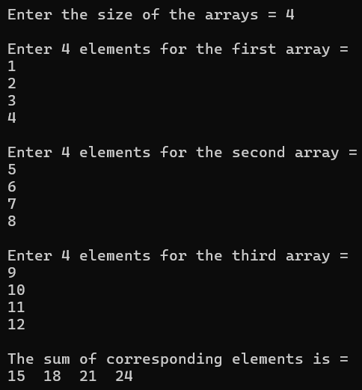

1. Write a program for linear search using the concept of dynamic array (Note: Program should handle the situation if item is not in the list).

#include <iostream>

using namespace std;

int main()

{

int* dArray;

int size, target;

int result = -1;

cout << "\n Enter the size of the array = ";

cin >> size;

dArray = new int[size];

cout << "\n Enter " << size << " elements =\n";

for (int i = 0; i < size; i++)

{

cout << " ";

cin >> dArray[i];

}

cout << "\n Enter the element to search = ";

cin >> target;

for (int i = 0; i < size; i++)

{

if (dArray[i] == target)

{

result = i;

break;

}

}

if (result != -1)

{

cout << "\n Element " << target << " found at index " << result << endl;

}

else

{

cout << "\n Element " << target << " not found in the array." << endl;

}

delete[] dArray;

return 0;

}

**Output**

